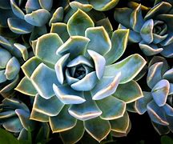Mindfulness methods can help foster a holistic mind body connection and include:

* Breathing Techniques
* Meditation
* Yoga

Meditation promotes equanimity and clarity, teaching us to *love ourselves* as well as others, whilst making compassionate decisions. Neuroscience is progressively reinforcing the idea that mindfulness and meditation [helps enhance perception, awareness and complex thinking.](https://www.ncbi.nlm.nih.gov/pmc/articles/PMC4109098/) When challenging situations come into our lives, quite often we can add to the drama, which can then spiral into negatively affecting our overall wellbeing. Mindful meditation can help us look at situations with an empowering perspective. The healing power of meditation helps us to become an observer of our thoughts, and if these are not serving us, we learn to let them go. We learn to separate from the [ego.](https://en.wikipedia.org/wiki/Id,_ego_and_super-ego)

There are people who have been meditating for decades and on some days find they cannot calm the mind - this is normal! We can simply acknowledge our mind and say ‘Okay, meditation is not working today so I will try later’.

**Mindful meditation benefits:**

* Decrease in stress, depression and anxiety
* Stronger immune function and rejuvenates at a cellular level
* Better sleep
* Improved mental clarity, memory, decision-making and focus
* Promotes creativity and mindful breathing
* Fosters a loving compassionate attitude
* Anti-ageing effects and supports pain management

Toxins are responsible for many health conditions and mindful breathing can help flush out these poisons from the lymphatic system. Stress response produces cortisol and adrenaline which can:

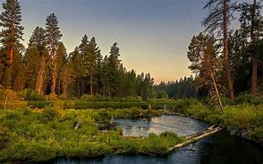

* increase our heartbeat
* muscles become tense
* breathing is shallow
* immune system becomes compromised

Anyone can have persistent [‘monkey-mind’](https://en.wikipedia.org/wiki/Monkey_mind) wandering chat, which can be detrimental in our lives. It has been said that anxiety and depression are mainly caused by distorted thoughts in our minds. Mindfulness meditation teaches us to observe pain or worry when they arise. By consciously slowing our breath down we can help bring a better sense of control for our mind. We begin to understand ourselves better; gradually learning how to neutrally distance ourselves from our thoughts.

*“Research on mindfulness-based interventions (MBIs) has increased exponentially in the past decade. The most common include Mindfulness-Based Stress Reduction (MBSR) and Mindfulness-Based Cognitive Therapy (MBCT). MBIs have demonstrated efficacy in reducing anxiety and depression symptom severity in a broad range of treatment-seeking individuals. MBIs consistently outperform non-evidence-based treatments and active control conditions, such as health education, relaxation training, and supportive psychotherapy. MBIs also perform comparably to cognitive-behavioral therapy (CBT). The treatment principles of MBIs for anxiety and depression are compatible with those of standard CBT.”* **

Mindfulness, breathing techniques and positive affirmations can be done anytime, by anyone, or anywhere. Please find below some of my favourites, which I quite often do outdoors while forest bathing. For more information on forest bathing, check out the [resources](http://www.naturespiritsuk.com/resources) section on Nature Spirits UK. You will be amazed how your mind can feel anchored into the present moment by just focusing on your breath.

**Breathwork:**

1. 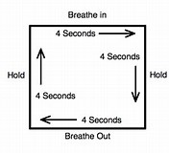The ‘Box Breath Technique’

Box breathing, or four-square breathing, is a technique using slow, deep breaths. It can enhance focus while also being an effective stress reliever. This can be used anywhere at any time!

1. The ‘4-7-8 Breathing Exercise’

This is where you breathe in for a count of 4 through your nose, hold for a count of 7 and breathe out through your mouth with a swoosh sound to a count of 8.

**Mindful Moments in the Forest:**

What you need:

* 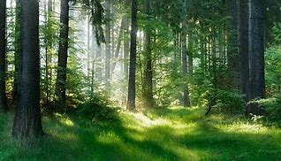Weather appropriate clothing
* Sitting mat
* Water, snacks
* Phone *(for emergencies only, if you get lost or to look at this document)!*
* Notepad and pen
* Toilet roll!

When we first enter the forest, try slowing down the action of walking. By going off track for example, following a deer path, hugging a tree or sitting under one, can bring wonderful sensory experiences of connecting to nature. Using our senses while focusing on the present moment can bring an opportunity to practice gratitude.

* What colours can you see? Thank you for my eyes that can see.
* What sounds can you hear? Try not to judge the sounds.
* Stop and listen, is it the birds; the branches creaking; the wind blowing the leaves? Go general and keep it simple. Thank you for my ears that can hear.
* Can you smell anything?
* Touch the plants and close your eyes. Use the box breath technique. Thank you tree for the oxygen I breathe.
* Can you feel a gentle breeze on your skin?
* Take your socks and shoes off feeling the Earth beneath you. Write in your journal, make it a ‘mind dump’ if you need to. Many people believe more creativity flows from us while from sitting under a tree.
* When drinking and eating, try a little [tea ceremony](https://integrativeinitiative.com/2019/11/17/forest-bathing-big-medicine-for-big-and-little-people/). We can also [forage for some plants](https://forestryandland.gov.scot/blog/foraging-eat-your-way-closer-to-nature#:~:text=Foraging%20involves%20directly%20picking%20plants%20found%20outdoors%2C%20such,our%20favourite%20foods%20to%20forage%20throughout%20the%20year.) to make the tea.

**Meditation Body Scans** can be done lying down by focusing our attention on our bodies by starting from the feet upwards. What sensations can you feel? Can you feel the life-force in your body or aware of any pain? This can often be a way in which our bodies are trying to communicate with us to make a lifestyle change. Also, [hatha yoga](https://en.wikipedia.org/wiki/Hatha_yoga) postures in [MBSR](https://www.mentalhealth.org.uk/a-to-z/m/mindfulness-based-stress-reduction-mbsr) are regarded as mindful stretching.

**Positive Affirmations:**

* I am creative
* 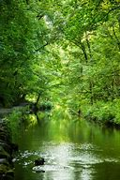I am important
* I am a good person
* I love who I am
* I welcome challenges as they help me grow stronger
* I will be okay no matter what, I got this
* I have the power to make my life what I want it to be
* It’s okay if someone does not like me
* I know a lot of people love me
* I have a great personality
* I am filled with love and compassion for others
* No one’s opinion will ever define me
* I love to learn
* I am beautiful
* I am respectful and helpful
* I improve every day and I am a winner!

**Some little words of inspiration:**

“Each morning we are born again. What we do today is what matters most.’ - Buddha

“We must become the change we want to see” – Gandhi

“Life is not about finding yourself, Life is about creating yourself” – George Bernard Shaw

“Absorb what is useful, discard what is not, add what is uniquely your own” – Bruce Lee

“The only journey is the journey within” – Rainer Maria Rilke

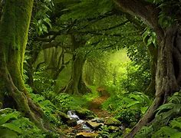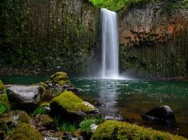

**References / Further Reading:**

* [History of Mindfulness: From East to West and Religion to Science](https://positivepsychology.com/history-of-mindfulness/)
* [The Neuroscience of Mindfulness](https://www.psychologytoday.com/us/blog/your-brain-work/200910/the-neuroscience-mindfulness)
* [Mindfulness-Based Interventions for Anxiety and Depression](https://www.ncbi.nlm.nih.gov/pmc/articles/PMC5679245/)
* 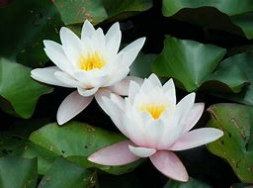[Why Schools in England Are Teaching Mindfulness](https://www.mindful.org/why-schools-in-england-are-teaching-mindfulness/)

If there are weeks where you are challenged by time to get into nature, my suggestion would be to try to do 15 mins of mindfulness practice by focusing on nature photos. You can find some in the [gallery](https://www.naturespiritsuk.com/gallery) at NSUK.

**Hopefully this FREE/** [**donation based**](https://www.naturespiritsuk.com/shop-donate) **download will be of value in your life.**

**Namaste, Love, LuLu x**

**Founder, Nature Spirits UK**